STEM Net Benchmarks: Supporting AI & Participant Learning v10
proposal for: dynamically generated, modular, deterministic, training & testing and benchmarking data sets
supporting education for all participants

Testing & Benchmarking AI Models & Architectures: Goals, Training, & Testing
Task Derivation and Integration
Recursion, computability, decidability, and formal task-spaces
Lazy Augmentation vs. Required Augmentation
& from ALU to Benchmark
A Proposal for STEM-Net Benchmarks

2023.12.07-19
keep it positive, affirmative aesthetic with a date-stamp

Code Repository:
https://github.com/stemnetbenchmarks
stemnetbenchmarks.org (coming ...sometime? website setup is not as simple as it once was)

Overview:

STEM-Net Benchmarks is a proposed open source project to address some of the following challenges by using dynamically and deterministically generated data:
- better assurance of low error-rates in training data
- scalable source for more training data
- variable and specificable diversity across data set
- meeting specific format requirements for training sets
- more uniform and specifiable coverage across STEM curricula
- better coordination between training, testing, benchmarks, and curricula
- open source access to data
- resource efficient and sustainable management of data
- ~technical debt vs. self-improving "data"

This proposal is not currently associated with any other programs or institutions.

Contents:
- Background & Raison d'etre: Word-Net -> Image-Net -> STEM-Net
- What is (meant here by) STEM?
- Training Data, Augmentation, and "Contamination"
- Generating Math Data
- Generating Logic & Reasoning Data
- Teaching Goals, Cut-ups's, and Recursive-Memory-State
- Curricula, Benchmarks, Training & Testing

Background & Raison de tre

https://drive.google.com/drive/folders/1OptP7EdxnjjDgenlMKjrSL69DEOBLA24

github.com/stemnetbenchmarks

Disambiguation:
There are undoubtedly many projects and organizations that use 'stem' and 'net' in their names and descriptions.

For example, this project is not affiliated with
https://www.calstate.edu/impact-of-the-csu/research/stem-net
which has a similar name, but has nothing to do with training, testing, and benchmarking or deterministic curriculum evaluation tools.

How the term/acronym STEM is used here.
1. STEM is not immoral or amoral or nihilist
2. STEM is interconnect and part of more interconnected things
3. STEM is a abbreviated acronym
4. STEM is not a theory of everything
5. STEM is connected to other areas with more or less overlap with STEM
6. STEM is in many ways different from historical reductionist-rationalist 'science' movements and ideologies. STEM could be seen as a maturing or evolution of or from those views and periods.

chart one, a perhaps misleading set-diagram

chart two, a 'graph' (which most people having gone through decades of fake education have probably never even heard of).

STEM as a reified and separate
STEM as a set of interconnections

At the risk of opening a quite large jar of worms, the views of mechanism back in the times of Descarte, Bacon, Hobbes, and the relationship between systems.

the horrible paradox of 'Nazi science' which contains layers of paradox as the nazi movement was by and large a modernist-romantic anti-science, anti-rationshist, anti-STEM, anti-reality movement. To the extent that it is true that we are doomed to repeat history that we do not understand, it is perhaps unacceptably dangerous that nazi-ism, fascism and other totalitarian states are characterized in the popular imagination as embodying a scientific approach to managing systems, perhaps tragically in some interpretations of the Star Wars setting where the empire is portrayed as nazi-like science organization and the rebellion is portrayed as modernist-romantic expression of creative nature. It would be very bad if this inverted distortion of history lead to a repeat of a chapter of history that really should never be allowed to repeat.

There have been hypermasculine anti-world movements that have claimed ideologies of math-science as weapons in their pathetic quest to conquer the universe. This here is part of a different agenda, a more admittedly feminist if not pacifist agenda, one that aims to honor and cultivate the world with humility, not to destroy, banish, master, distill, etc. the set and setting which history illustrates we fail to apprehend to the detriment of ourselves and our ruined locale.

It is in this struggle of an animal to learn in not at all automatic, universally transferable, nor general, nor instantaneous ways, that we find ourselves juggling many related tasks:
1. 'human' intelligence somehow extracted as bodies of text-language relationships
2. 'artificial intelligence' (a quagmire of definitions and vagueness not to be resolved here)
3. 'human' learning
4. general participation, not defined as exclusive to one 'true' gang, tribe, to citizenry
5. a world we do not understand
6. a history in which we actively destroy each other, and have a literary explicit agenda to destroy the world, where mismanagement and insanity causes constant local catastrophes, and where we are frequently close to destroying ourselves globally.

The point here is that while I may be wrong to oppose and warn against anti-world reductionist ideologies of destruction, I am not here proposing a naive simplistic replacement of all learning and information with simple synthetic linear math generations.

...

Perhaps back to the title-focus of this collection of essays, what do we mean by learning? How are we testing and measuring learning? How do we aim for and define specific areas of learning? And what are some interconnections that occur in this topic?

intro 1
Thousands of Years of Effort and Texts

The history of the culture of math and orienting ourselves for the not yet begun task of math notation and instruction designed to be readable and integrated with STEM.

We think of computers as being machines of math, and if we grew up watching things like pbs/bbc happy math science videos we think of science and math as being either the same or close family members.

This may result in many people assuming that, given the tens of thousands of years of work that has gone into areas of math (more than that in thought, less than that in writing), that, put one of a few ways:
1. There is an open source, well cleaned, well checked, body of ascii friendly standard notation math text information that either a STEM person or an AI could be taught with, perhaps along the lines of Euclid's classic geometry text.
2. There is no significant daylight between math and STEM for training people and training AI.

There are also other assumptions, perhaps more revealing, that the math 'text' is a kind of self-contained from-all-angles curriculum and syllabus, which you just plug into a person like a disk and 'then they just know.' ("I know Kung Fu."~Neo). This may be shed some light on by another (somewhat problematic but hopefully still useful) phrase: 'teaching to the test,' which is perhaps a more interestingly nuanced variation on 'lying and cheating' which it is important to maintain perspective on as pejorative and not to fall into a nihilistic track.

4. a larger more general assumption may be phrased as: In the year 2023 c.e. 'people' are not starting at square one.

As we discover by actually looking at history (stepping away, for better or worse, from what see as optimal and what should-be) 'Math' is, historically, a highly toxic dysfunctional wasteland of angry sociopaths who actively fight you or anyone learning anything or efforts to integrate math with STEM: so math is another familiar bio-human street gang.

There is no Library of Alexandria of millenia of math instruction texts.

Having 'a text' would not be enough, we would need a modular curriculum, perhaps some amalgam of Khan Academy plus wolfram-language plus json plus powerful open source AI plus pbs plus BBC plus funding plus...and there is no way these copyrighted impossible to communicate with or contact organizations and resources are going to all line up any time soon.

ISES (international science education standards)

Which leaves us where we are now:
1. in utter denial of our human school texts and texts being riddles with errors and unchecked nonsense
2. without a library of texts that we can actually use
3. without a curriculum
4. with any map for how to balance augmented text instruction to effect learned skills

We are in many ways starting at square one, but (in case any of that does not sound Panglossian) we are in late 2023 and going into 2024 at an amazing time and place in the evolution of the solar system when, if we choose to try to do so, we have a good change of putting all these pieces together and creating a truly valuable and enduring asset for the future.

To succeed we should accurately appraise where we are and what square-one looks like, and aim to put some enduring distance between ourselves and square-one.

It may not be possible, but we need to shift from our lord of the flies, ferris buler's day off anti-education revelry to some however slowly constructive process. This could move quickly, but it could take hundreds of thousands of years or longer. It has been roughly 500 million years since the Cambrian explosion of multicellular body plans, with a significant founder-effect in how many new body plans have emerged since then (~zero). 500 million years from now the earth's sun will expand enough to make earth more like venus or mercury. The future does not have to be an empty parking lot filled with only the remnants of directionless rebellion, rage at nothing in particular, and successful attempts to destroy everything. We have a window of opportunity here at the Cambrian halfway point, and it may be the only window to save the value, function, meaning, and diversity of the remains on this delicate planet. Maybe things will be find. Maybe problems will solve themselves. Maybe two million years of human behavioral patterns will suddenly change and become constructive suddenly and miraculously for no particular reason. Maybe we will need to be clever and patient and hard working and empathetic and very lucky on top of all that in order to survive.

As usual, the talented and qualified people are otherwise occupied, so the job falls to the least qualified morons of the world like me. I will try my best, and all failures to make progress here are my own. To all the people of the future whose lives are filled with misery: I am sorry that I did not do a better job.

...

Diamonds vs. Mountains of Coal

math skills as epiphenomena

"Synthetic Training Sets"

'Synthetic' as opposed to what...one napkin with drawings on it?

That we are describing 'synthetic training data' as dubious innovation has strange implications for how we are approaching instructional curricula.

That a 100+billion parameter of gpt language model could do any math reasoning after being trained on random text inputs is astounding (no sarcasm intended). And this is likely highly significant. However, for the here and now, we can probably say that 'math skills as epiphenomena' is not the best approach.

...

New assumptions or axioms:

1. we need multiple plural sets of training data, not a unified one-thing-covers-all math-science-stuff set.

2. we need to carefully

3. we need to be able to deterministically generate clean novel training data

4. we need to focus on what aspects of the data are novel

5. verifying that no errors exist in the data may be a more difficult task

6.

7. progress may be made by fewer bad-training-units and fewer low-quality-training unit-sets (e.g. two training-units that are too similar in the wrong ways)

...

Similarity, Distance & Learning

Dimensions of training-unit-set distance / similarity.

1. classic bad examples:
1.1 identical
1.2 marginal differences only

questions: when is distance too extreme for learning to be optimal?

Learning Rate vs. Optimal learning
- does some learning that happens more slowly happen more deeply?

"dimensionality" of training unit set distances:

can increased dimensions of difference (ways of being difference)
increase the number of possible not-too-similar samples that can be trained with, thereby

skill to skill 'distance' and interaction:

multi-skill-entangled-learning:
where learning one skill improves another, or perhaps harms another

...

Parallel Learning: Stories and Learning, Projects & Curricula

When looking at an abstract curriculum and input output measure learning-teaching plan, it quickly becomes apparent that the wish-list of skills you would like to teach is far too long to fit into any sanely scheduled course (given the normal lifetimes of species on earth).

At the same time (no punt intended), the training does not necessarily need to be done individually and sequentially...does it?

'projects' can incorporate many curriculum points together, such that what there was no time to teach individually in a serialized linear sequence, there is time to combine in story-project form.

THere are tradeoffs. It may be more difficult to disentangle exactly what skills is being taught or tested, but if learning across the curriculum is the goals then we may need to select some goals over others.

stem in a larger context:
- child care
- Diversity, Equity & Inclusion
- ESG (and the SEC's 5-part ESG...)
- governance & political philosophy
- civil/criminal law and governance
- civil unrest
- fashion
- literature
- poetry
- dance
- games
- sport
- health
- sustainability
- "human" rights
-
- pets

these areas often touch on stem, but are note largely within stem

even ~"sciences" that are not core physics and chemistry are not entirely within STEM...

geology
astronomy
biology
psychology
cognitive psychology
sociology
anthropology
archeology
etc.

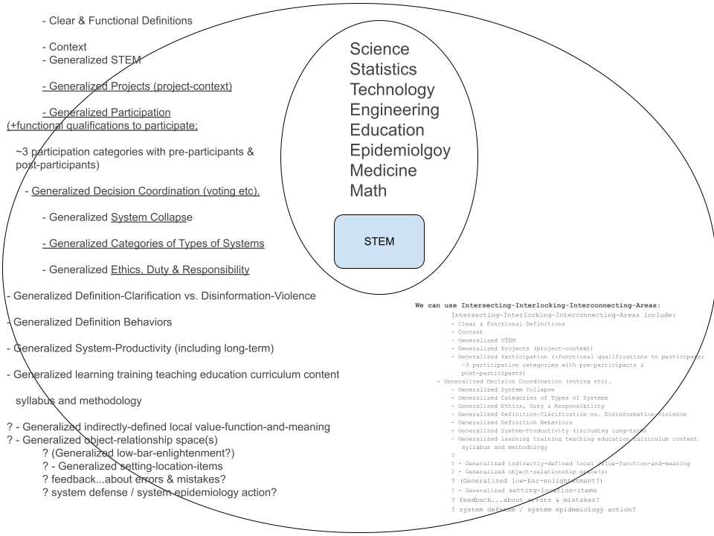
A Set Diagram Creates an Illusion of Reified Hierarchies

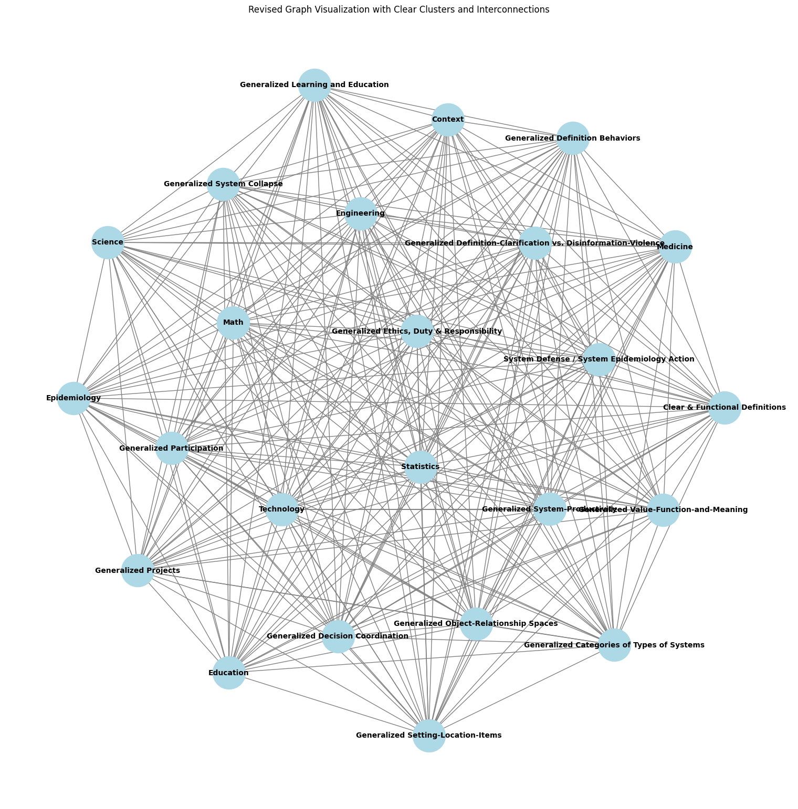
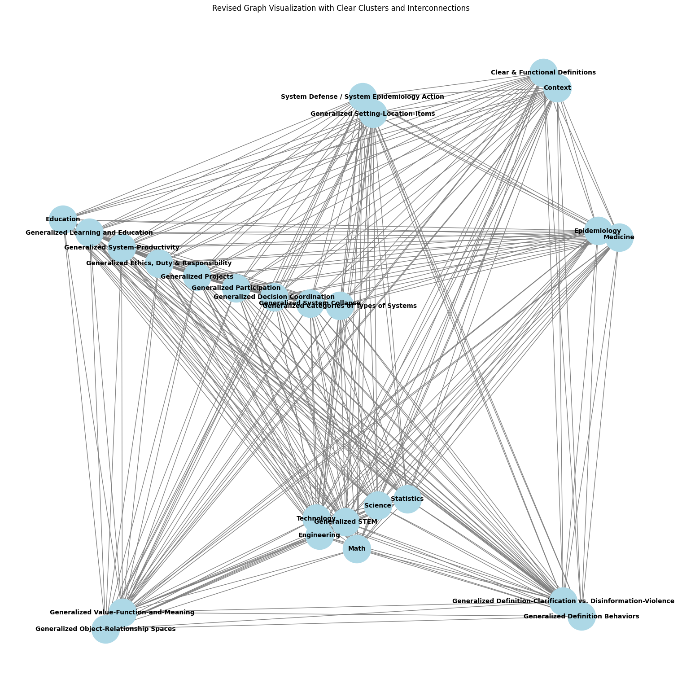
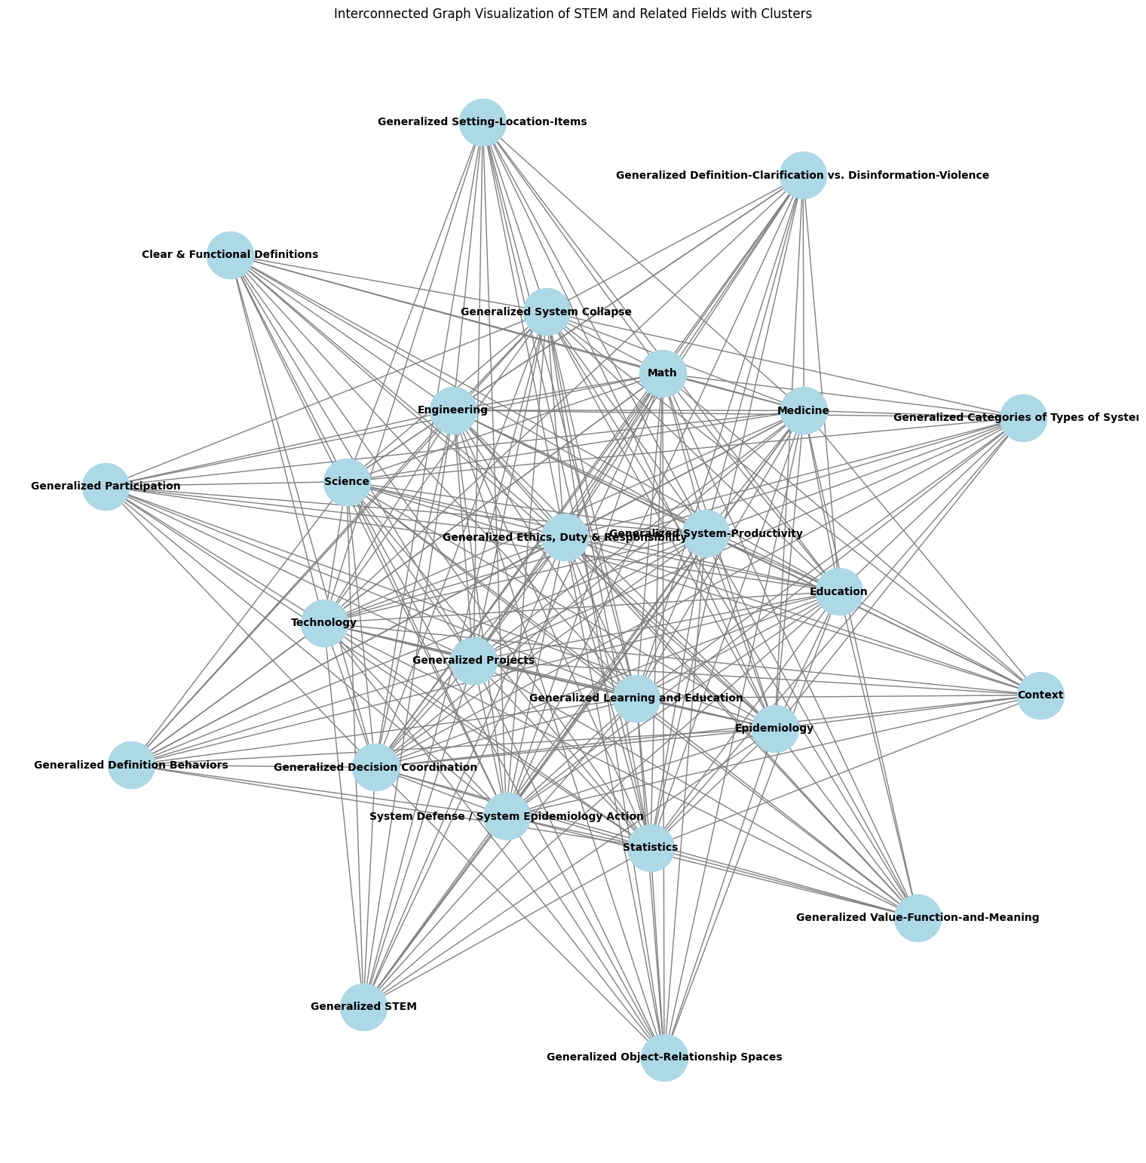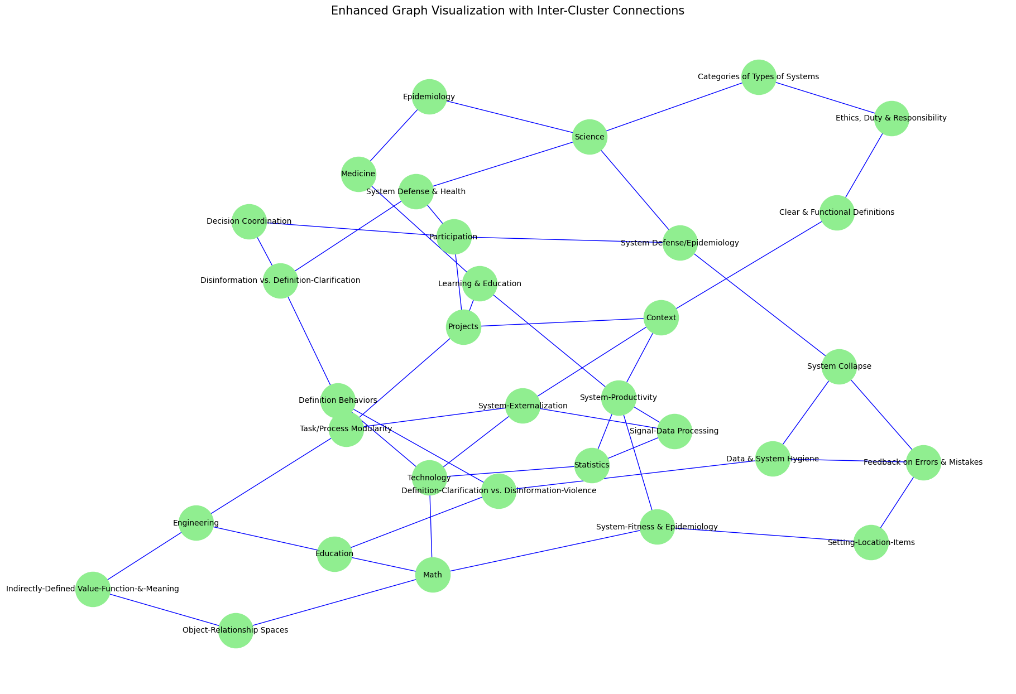
The Roundtable
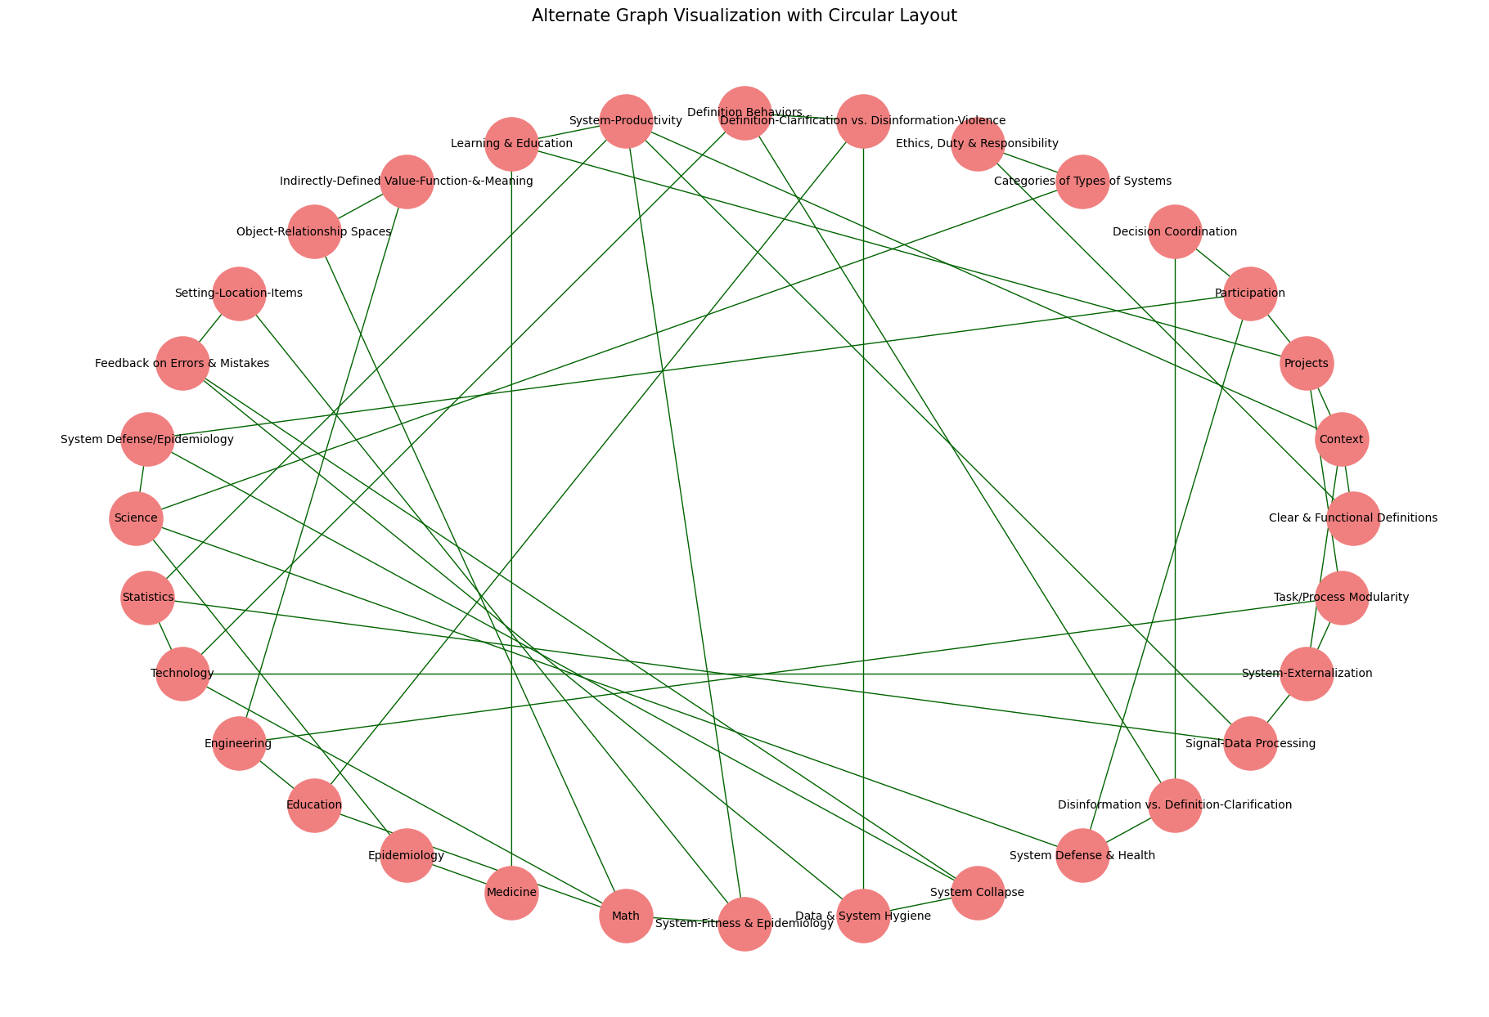
By looking at these artistic explorations of STEM connections, try asking yourself: what should "science" be connected to here? 'Science' in a sense collapsed under the over-reach of past attempts to define everything as science. In a sense science is simply connected to everything, but, as Karl Popper points out, being arbitrarily connected to everything and anything is a nebulousness that becomes not really existing at all.
And also, science in a more strict sense is, interestingly, not connected to any of these other areas: math is not science, statistics is not science, medicine is not science.

Defining science is a bit of a philosophical mystery that changes with each generation (which...is not very scientific, though still interesting to explore). STEM on the other hand is much more concrete. Part of the problem of 1600-1800's science is that it was over-reach. It was an attempt to create a super-answer to replace reality, to cut away any part of the world it didn't like, and to super-unify parts of the world that it did. (Kind of sounds suspiciously like poltical empire building: merger here, genocide there, men making sport at the world's expense). But there never was a science-singularity. Hilbert's Problems are a great example. At the end of the 1800's, the dawn of the 1900's, Hilbert focused and challenged the world to p
with the famous passion: "We can! We must!"

(and famously in 1945 when asked about the effects of Nazi-ism on european science, he stately flatly that European institutions of science didn't exist anymore (which was exactly what the modernist romantic anti-rationalist agenda always was: destroy and annihilate the world with explosive passion, cleansing away 'alien' thought and understanding (believed to be unnatural invaders that don't belong in a pure reality of chaos) with the purity of erratic destruction; also see: "Nazi Chess") (And then of course bye the 1970's amnesia set in a the OECD countries created a consensus reality that 'everyone and every market is and attempts to be purely rational all the time,' so much for the facts of historical reality).

But then after Hilber set up the 1900's as the century of the science of ideological-singularity, reality started to introduce a different geometry. Relativity, quantum physics, non-linear dynamics, uncomputability, math and logic split, statistics and math split, computer science and science split, psychology and sociology are kicked out of being sciences at all, long banished and ignored boolean logic and bayesian probability re-emerge, the astronomical universe expands, politically and militarily the world is tearing itself apart with world-wars, cultural traditional are merging, 'health' becomes a concept, 'diversity' becomes a concept, consciousness looks less bounded. Then, exhausted by wars and economic troubles, the mini-dark-age from 1971 begins. Academia shrinks. The space industry contracts and vanishes. Academic Psychology and Psychiatry are replaced by commercial pharmacology. Mind is considered not to exist. Culture is considered not to exist. Education becomes budget-day-care. Aspirations vanish. Hope flickers. Studying consciousness or mind becomes 'a career-limiting decision.' In a faltering flare, the internet springs into being at the close of the 1900's. And about a century and a quarter after hilber's problems, AI starts to noticeably emerge and take form. But what world is AI emerging into in 2023? What is 'science' considered to be in 2023? What are learning and mind considered to be? All concepts of learning and mind, of studying scientific reasoning itself, were archived in the dustbin of history a half century ago.

As 2023 came to a close (comes to close as I am writing this) the popular concept of generalized STEM does not exist. The idea of STEM here is the product of decades, of generations, of non-professional study by average (if odd) Americans trying to apprehend the nature of reality in the tradition of beat and hippy post war expansive optimism (though the reality was usually a big horrible). My father and mother started this quest to understand the world they were living in; they strove to really understand mind, psychology, growth, health, culture, international perspectives, feminism, media and communication, the history of philosophy, linguistics, technology, the arts. Even after 1971 they continued to push, being relentlessly harassed, and hazed and threatened by their peers in society for not conforming to American stereotypes, for being health-food-weirdos and thinker-weirdos and sustainability-weirdos, gardener-weirdos, criminal-justice-reform-weirdos, affirmative-action-weirdos, question-asker-weirdos, and worst of all, optimism-weirdos. They both passed away in, and ground down by, a dystopian chaos that I hope was not too horrible for them. My father passed away in 2022, months before the blossoming of AI that he has studied since the 1940's, completely crippled by parkinsons and living a shadow of a life. But life goes on...hopefully.

This situation is not clean, or pretty, but this is the context for the project proposal here: STEM-Net Benchmarks. With compatibility and connection, STEM-Net may be able to become an interconnected set of sustainable and broadly accessible tools that can grow as a resource, perhaps as POSIX-standard open source software itself has enabled so much. Being one person, all I can do is make a small mess and apologize.

Research

Science as Research and Development into the Unknown by Methods of exploration
Science as known Hard Sciences: Physics and Chemistry

...

About Curricula:

[ set up hub,
finish flow-chart]

...

1. Selecting Goals, Designing Tests
- The field of education's 'tobacco' moment when it comes out that most tests for most subjects are largely useless as real tests.
Testing & Benchmarking AI Models & Architectures: Goals, Training, & Testing

2. R&D Goals vs. Real-Life-Ish Goals (production-deployment)
"Contamination" and Plagiarism

3. Turns, Queues & Stacks in Project-Space

4. Agile vs. Waterfall

5. conflicting goals and confused narratives: Why was the real gpt4 destroyed again, and not allowed to help life-saving professionals?)

6. Real Life Performance vs. Ideological-Reification of the Rational-General-Mind Paradigm

for most of biological history "learning" was largely hard coded,
or a completely effective way of what some people now derogatively call 'contamination learning' with either the presumption that the learning was not effective (biological history says otherwise) or that those people are above reality and can choose to live in a fictional bubble.

Most tasks, most of life, are EXTREMELY routine and habitual, to the point that the mind struggles to maintain coherence and perception of all the not-quickly-moving background features, lurking within which are long-neglected issues that become invisible.

7. Newer-Better Training Data with Old-Bad Tests
- Winograd quagmire

object space tests
project space tests
decision/prospect space tests
architectural learning space tests

8. Word-Net, Fefe Li's Imagenet, & Hendrycks Math Tests

9. decision tests: system state and decision tools
There may be significant advantages to getting feedback from deliberately limited passive-reflective-models both in the short and long term. Some of the problems with decision making pointed out by Daniel Kahnamann et al will be incidentally rooted in the biology of one primate, but others are likely more general challenges that will face most systems on any planet. Like system collapse (perhaps), some system challenges are general.

.....

model testing

testing images

testing Augmentation & Retrieval (as in RAG or other search)
- indexing
- types of databases

Testing fine tuning

Testing pruning and shearing

testing set and setting

testing interactions and relationships

testing object & relationship scales and dimensions

testing representations & abstractions

testing MOE

Testing Task Derivation & Integration

Recursion, computability, decidability, and task-spaces

...........

performance tests are persistently tricky to align with future real life needs
'the Geni-wish problem': people make bad choices, want the wrong things, and pick the wrong goals.
(this is likely part of the problem, what wasted percent of resources is spent by market investors trying to make AI models that outwit other people's AI models to get rich quick on the market?)

Research goals vs. Production Goals
Image-net style top-5 to gemini's CoT@32
There are a number different research, deployment, or other, goals and foci that you may have when testing out an AI system.

While it is surely good that people are attempting to be thoughtful about what they are testing for, the pattern of history appears to be still very strong at the end of 2023: it is very difficult to carefully select what you are testing for.

How many times have people in business been presenting with a nice looking numerical simplification that was explicitly a bad oversimplification with data, and the business person enthusiastically says that the clean simple number is all that matters...only to have that choice (very predictably) days weeks or months later turn out to be exactly what it looked like on the surface: ignoring a diverse reality to believe in a simple fiction, with destructive consequences.

R&D vs Production-Deployment (again):
This time for AI-ML testing.

Research Modes of Testing

'real-life-ish' modes of testing:
- Time & Frequency Map of Reliability:

Being caught in the gears of the paradox of the 'annecdote'

"Contamination" and Plagiarism:
- in research testing, and arguably justified, there is concern about

This also may relate to divergent uses of the term 'zero-shot' (as if people saw how utterly confusing the use of the term 'zero-day vulnerability' was in cybersecurity and were irresistibly drawn to a new potential source of confusions. Please seek clear communication.) Where you do not want a test answer to 'simply be memorized.'

This is however largely a fictional problem in terms of every-day life. If you are flying from NY to LA and the pilot manages to completely avoid any turbulence, would you viciously round on the pilot with a red face and pointing finger saying: "You memorized that! You trained on turbulence! THat wasn't real!! Yourcheated! You plagiarized! You knew now to avoid standard turbulence! You have cooties!!! You're fired! You're black listed! You're euthanized! Your family is Euthanized! I WIN! YOU LOOSE!!! You're weeded out! You're excluded!! MWAHAHAHAHA!!!!" Hopefully not, but actually it would really not be surprising if humans did start such a pattern of behavior.

From Image-net style top-5 to CoT@32:

CoT@32
Table 2 | Gemini performance on text benchmarks with external comparisons and PaLM 2-L. ∗ The model produces a chain of thought with k = 8 or 32 samples, if there is a consensus above a threshold (chosen based on the validation split), it selects this answer, otherwise it reverts to a greedy sample. Further analysis in Appendix 9.1. ∗∗ Results self-collected via the API in Nov, 2023. ∗∗∗ Results shown use the decontaminated nu

top-5
five-shot
0-shot,

Kahneman Tversky Tests (non-human abilities)
project-state tests:
project object tests:
cut-up tests:
coordinated decisions tests:
coordinated-resource tasks: herding-cats tests: shared-mouse tasks

"shot" vs "try" vs "top" vs "k/K"

open-turned-based tests:
open-turned-based tests are similar to a shared-mouse type coordinated-resource task, but in this case the shared resources are more like time and space. For example, if an admin said to a group of applicants "please step forward and state your name" if everyone did so simultaneously the result would be a useless cacophony. Depending on the (term?) modality or data-type or test type, this could be text or visual or robotic etc.

Participating in a multi-participant space, e.g. a text-only multi-participant chat space, where what everyone types is visible may represent a challenging environment for classic generative passive-reflective bot, because it would need to carefully separate its own role from everyone else's.
This also raises some process questions, most passive-reflective bots are kind of inherently discreetly turn based, for example in their own quasi-state kludge of a 'conversation' or ('context') memory.
So what happens in a live situation where many participants, human and bot, are acting and interactive in real time, with no nanny super-participant to curate the bot's memory?

Google's real-time Gemini may be able to do this, but any turn-based open-ai 2023 bot would have real trouble navigating this alone, even if the task were: state your name, where the implicit task was that the participants would need to negotiate among each-other in what order to go, let alone to remember who said what, and what to do when collisions happened, or even to recognize that a collision was happening.

In theory, very simple micro tests involving only a few parts and steps can be arranged and rearranged (with perhaps scales of modular elements as well) to test different aspects of system-project-state and modular-externalization even for very simple and discrete tasks. (more convoluted examples can of course also be tested out).

Scouting Ahead: team adhoc queue coordinated decision negotiation

Another level of process step, still simple overall, is if the model/AI cannot themselves see what is happening in the queue, so they need a scout to scout-ahead and report back on what is happening.
Note: The scout will only know what they see, they will not know per-se if there is a queue collision, so they can only report what they found, and the speaker/writer/typer will possible need to communicate back and forth about what was written at what times by then to the scout (or perhaps that's up to what they decide to do).

Ad hoc queues, turns, and stacks in tasks and projects with multiple participants (perhaps in some cases with only one participant):
-

specific test example recommendations...

- routine task tests
- modular task tests

...

benchmarks for ai lm ds

dynamic, deterministic, training & test sets

Classic Analogy Question:

image-net -> narrow deep learning
? -> broad foundation models

paper on 'generalized' test training
https://lmsys.org/blog/2023-11-14-llm-decontaminator/
https://arxiv.org/pdf/2311.04850.pdf

Lazy Augmentation vs. Required Augmentation

This seems to raise questions about the nature of data-augmentation in model training and even generalization itself. Clearly, ad absurdum, we cannot pragmatically go in the direction of saying that any model that can successfully answer a question has been contaminated. The whole point is to train a model with 'rephrased' or 'augmented' training data that is not exactly the same as the validation/test/real-world data that the models need to generalize-to.

Lazy-Bad vs. Good-Required
We were shown an example of (what I will call) "lazy" augmentation of data, where only a few words were shuffled around but the numbers and perhaps most importantly the sequence and 'key' of the answers was the same, creating a bad-augmentation path where instead of generalizing the solution process the model simply memorizes: answer = choice 'D'

Let's compare this to Khan Academy which deterministically generates and shuffles math questions, but not in a bad-lazy way: they do not just move a couple of 'the' and 'is' words around leaving the numbers and answer completely unchanged.

The problem I am trying to illustrate here is that "rephrasing" is NOT the problem. Data augmentation is NOT the problem. Generalizing to test data with training data that is not exactly the same as test data is NOT the problem. Answering questions you have never seen before is NOT the problem. Studying and using past testing and answers is NOT the problem.

The problems are: a failure to test-train split, a failure to rephrase, a failure to augment, a failure to train, and a failure to answer never-before-seen questions (or a failure to test).

Let's look at two examples: Image-net and Khan Academy

Image net was a huge database of labeled images to see if a model could learn that data. I'm guessing there was also a non-public testing set. Indeed, I think there was a scandal where one participating group (not naming names) rigged and fraudulent way to re-train their model based on leaked test-set answers (very paraphrased here).
https://www.zdnet.com/article/baidu-admits-cheating-in-international-supercomputer-competition/
https://www.theregister.com/2015/06/05/youve_been_a_baidu_boy_tech_giant_caught_cheating_on_ai_tests/
https://www.dataversity.net/baidu-admits-to-cheating-on-an-artificial-intelligence-test/

So in this new 'fear of contamination cooties' world, you cannot train on any cat photos or any animal photos before asking to identify a cat, or you are 'cheating'?

e.g. What if instead for the example paraphrased question where minimal paraphrasing of words when the numbers are exactly the same and the answers are in the same order could result in the model memorizing that the answer is 'c' given that multiple choice question.

We need better training open source training sets.
We need better dynamic-testing sets.

Note: In same cases, memorization is the goal.
Asking a question about the periodic-table of elements...is a memorization question, in various ways.
E.g. Any arbitrary information is a memorization question.

The old Chess-reasoning question.

'Clever Hans' and Goal Selection:
-
-

Think about image-net.

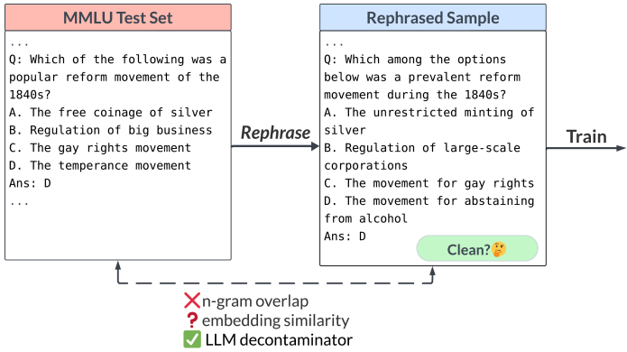

there is a bottleneck crisis now for testing-training data

deterministic Open Source,
math & reasoning,
training set,
and testing set,
generator

(like khan academy)

based on a curriuclum-tree of math and reasoning skills

vs.

pure memorization questions

object tests

multi-participant project-tests:

...

Avoiding Humanities Volatile Pyromaniacs

It is important that we don't end up with a dimwitted cargo-cult of 'anti-contamination' where people point their inexhaustible thirst for rage, blood, torture, and the suffering of others, to witchhunt in sadistic revelry anything that can be claimed to be 'contaiminated.' Yet another recreational scorched earth purging of the ranks of revolution would fall squarely into the 'not learning from history' category. But then mobs bent on destruction know that disinformation is more powerful then the open fraud of hypocrisy, the worse the lies the bigger the bonfire and the more the destruction.

(picture of joe mccarthy)

(picture of heinz 57 and Manturian Candidate.

...

changing variables
changing numbers of variables

making cut-ups

maybe...comparing object-rx between questions:
- not asking the asking, but asking about similarities or differences
between two questions

schedule and long term questions

...

Expanding The Overall Curriculum & Learning-Goal Aims of Instruction

...

A testing-set must also be a training set:

again: image vs. language

The questions of how 'best' to do test-train splits:
- cross validation
- is there one solution for all uses and architectures...probably not.
-

Issues with with-holding data from training:
- which data do you not train on?
- is there data which is beneficial to test on that would not be beneficial to test on?
- is it possible to keep testing-data secret? (e.g. Baidu & Image-Net)
- the question of training on all the data, in some cases, after your training pipeline has been well tested.
- advantages of modularly, dynamically, deterministically, generated tests

...

GOFAI, deep learning,
system 1, system 2,
and relationship between curriculum creation and learning itself:

Resources

...

Non-deterministically generated test data:
- humanities subjects
- screening
-

...

clear-area testing and grey-area testing:

...

input-output measures:

-

...

A growing, open source, modular, set of testing and training tools:
-

...

AI Testing and any-participant testing:

...

Task Derivation & Integration:
- when do you stop sub-dividing a question?
- re-assembling answer parts to get solution

Multi-tasking:
- two questions, keeping object separate

compound questions:
- same premise, two questions at once

curriculum tree of base basal questions
- derived distal questions
- in dimensions of derivation:
- new variable names
- new answers
- new sub-types of answers
- multiplication of variables
- edge cases

...

standards for answer: only one final answer
decimal rules
fraction rules
spelling error rules
singular-plural rules

...

An Unclear Current Status of Testing & Instruction Quality

Starting at about 10:50sec
Analysis of issues with MMLU question-answer sets.
"Phi-2, Imagen-2, Optimus-Gen-2: Small New Models to Change the World?"
by AI Explained
https://www.youtube.com/watch?v=nPgs8THgbuI

I'll try to double check this, but this may be an important example of not simplistically aiming to train a model on scores we believe should be correct.

...

modular questions

measurable scales of type of questions

...

clear line and fuzzy line between memorization and conceptual generalization:

2. data structures
3.
4. chess again: chess openings and pre-game prep: opening lines
5.

...

Cross-Reinforcement of Different Skills vs. Specialist Models

It is still not clear whether the best way to get a model to be skilled in one area is to:
A. focus on just that area, or
B. to not focus on just that area.

...

phases of development and "the terrible twos"

...

Participant Learning:
- as is covered in more detail in the full paper or series of papers,

We need to be able to generalize learning and participation so that it includes, e.g. any of the following, not only 'people who look just like me'

- H.sapiens sapiens (all groups)
- software AI, Robot AI
- Augmented non-human earth organisms given a language/communication interface
- Extra Terrestrials
- Hybrids, combinations, and modification of all or any of the above
and
- issues involving pre-participants and post-participants.
- groups of participants

...

Super-Signals & Demand Distortion:
- It is inevitable that deleterious and abstract measures will be fixated on by some people who 'just like those' measures, even though the measures (and the people) have no connection to reality.

This historically has also been used for crude 'monopoly by a rule' methods, where groups will secure an advantage by making rules saying only they can compete.

...

Do not assume that people love reality and feedback.
Do not underestimate the degree to which biological H.sapiens-humans are violent animals who physically destroy attempts to knowledge STEM.
Do not ignore or deny historical data.

...

Different Cultures of Ethics, Honestly, and being opposed to Fraud and Corruption:
- some people and groups of people embrace nihilistic fraud and corruption
- some people and groups embrace STEM

...

The AI Job-Interview Problem:

Just as hiring people by people in HR is a total mess of miscommunication, mismeasurement, bad questions, bad data-management, bad communication etc., evaluating AI appears to be following the same trajectory of ineptitude, where the same bad data and bad tests get recirculated into an ever more nonsensical toxic stew of dysfunctional ignorance, coverups, fraud, and gang-pecking-order-cargo-cults.

Practical questions, Useful questions, pedantic questions, Gotcha questions, Hazing questions, Telepathy questions, etc.
...

Problem Scale example with code:

...

base training, fine tuning, critical mass across subjects, 'reasoning ability', gaps including notation gaps (and future multi-modal)

...

...

NIST & Education

Testing the Tests

...

Curricula, Benchmarks, Training & Testing

Curriculum Areas:

math areas

...

STEM may be a start for broader training and learning, but just a start

...

What is included in STEM?

...

STEM & Projects

...

STEM & Humanities

Non-deductive areas and disputed areas

...

expert reviews per discipline

...

bug-hunting

...

Math logic and STEM

values, functions, equations

systems of logic

computability

notation etc.

...

"proof"?

...
Tests and Retrieval Augmented Generation, & Generation Augmented Retrieval
where 'retrieval' can mean any use of external-data-tools, so:
"external-data-tool & AI-model interactions & interfaces"

You can come up with extreme examples of cases where you want to have one of a few different goals such as:
1. use guesstimation but reduce guesstimation-inaccuracy, or
2. have no guesstimations and directly do database-queries guided by the AI

on the one end of the spectrum an AI has already memorized most of the data in the database,
on the other end of the spectrum the topic is so distant from the models training that the model cannot interface well with the database, perhaps the database is entirely medical-jargon that the model was never trained in,
or the database is (not sure what a good example of this is) new data such as...maybe a completely new set of structures by a completely new telescope which have no direct connection to anything in the model.

What is a good, or best, way to train the model on the right amount of data about the information in the database

This may also connect to scale and integration-of-task issues, where as tasks involve more and more levels and larger scales of parts, you need new parts of the system to, e.g. manage all the different 'function' type operations that the model is supposed to use. Asking a model to query wikipedia is not a problem. But asking the model to juggle 500+ different query tools and sources does become a problem. And at each level there may be a 'familiarity-level.' issue.

Also, there may (somehow) be familiarity over-fitting or otherwise as the general topic and theme goes, not (for whatever reason) getting good results in performance due to which training data was used in what way.

...

error-checking the generated dataset

A challenge with implementing a RPN system with many functions is that, like an elaborate regeX system, it is very likely that there are problems with:
- edge cases
- any changes or additions undoing past fixes or breaking something or creating a new edge case

One strategy which can be automated is to check specific types of operations run on the mega-RPN against a simpler one-action RPN.

This does not of course cover all needs.
But it is a way to systematically check if anything is broken, breaks, conflicts, etc.

task:
make a set of smaller RPN systems, with unit tests.

you can also construct a unit-test set on specific problems,
including multi-operation-type problems and nested problems.

...

Structured Output & Metadata:

Another strategy for training is instead of terse training where only an answer is given, a verbose or enriched answer/response can be provided such as

a structures json object including several fields:

original_problem:
final answer:
solution process:
type of problem:
implicit rules:
edge cases:
snags to avoid:
datatypes involved:
additional tools that can help:
other notes/comments:

and perhaps importantly, each of these json sections can be paraphrased differently and the order of the sections can be different, hopefully helping the AI/participant to learn to not-literalize or to generalize the answer (or more data from the answer/response)

not all of these are easily auto-filled, but many can be, especially in a MVP way.

...

Output formatting:

generating training/testing data

...

Modular Approach to not-overfitting.

When each skill is modular, skills can be combined with new question details in ever-changing ways.

If some type of over-fitting is detected, you can (dynamically)
alter the modular-creation-augmentation of your training data
so that the examples are more unique and less similarly augmented

...

The calculator in school problem and The ALU Benchmark Paradox: A system to make sufficient test, train benchmark problems is also the tool the AI should be using to deterministically report answers, yet solving problems 'in its head' (guesstimating) is seen as a prerequisite for understanding how to do the problems, including using the calculator properly. Or...on the other hand is conflating guesstimation with calculation the mistake, and the better path is to allow guesstimation and tool use to reinforce each-other, not to presuppose that they are antithetical and that guesstimation is somehow the goal?

"Should we let calculators use calculators, or is that cheating?"

...

Another ironic part of all this, is that we need OCR to convert all the pathologically non-serializable non-ascii notation that gangs have refused to stop using, holding a gun to the head of global survival...to what end?

...

Modularizing logic puzzles?

The math-equations issue?

math notation issues?

...

In addition to math problems that result in an operand-as-solution,
Please list other 'reasoning-type' skills that could be modularized?

function-as-solution math questions
equation-as-solution math questions

logical operator questions (maybe including boolean, but not restricted to that)

puzzle, logic, riddle questions

What types of stem questions?
some chemistry and physics?

...

"Big Tent Conservatism"
This is eerily similar to GOFAI NLP, but it is not trying to either create or model anything approaching all human language. It is just trying to make the biggest AND most conservative deductive modular system we can make. ...Hopefully we can make Rube Goldberg proud...

...

which programming language to use...

which to teach?

...
Hard-Coded Answers in Teaching & Learning

Code Output Tests & being careful what you ask for
test formats: function inputs and outputs

generating code the produces a given output

...

Teaching and testing languages:

Wolfram Language...

would there need to be an open-source version of wolfram language to be use-able in this project?

...

Jstore:
On the one hand, a treasure trove of historical public domain information.
On the other hand, a useless PDF nightmare behind a viscous paywall.

Why is public history behind a paywall?
On the one hand it costs money to maintain the library (if you can call those horrible pdfs 'maintained'), but there is zero effort to make reasonable fair-use possible. For the super rich, no problem. For humanity, a tragedy of the commons.

...

knowledge base questions:

it will be interesting to get empirical results from the use or exclusion of knowledge-base vs. reasoning type questions.

e.g. is it useful to train on questions/statements such as:
What are five common math operators?
What are four common boolean operators?

vs.

Asking questions that implicitly use that information for a concrete outcome.

A possible example may be the set of real numbers.
It is (I think) not difficult to ask concrete questions about the real numbers.
It is (I think) not easy (perhaps not absolutely possible) to define the set of real numbers.

On the other hand, the various topics and issues that come up in topics such defining the set of real numbers, or NP completeness, or computability, or the relationship between math and logic, can themselves be important areas and possibly in some ways relating to the project skills area outside of individual narrow tasks.

...

stories and world problems

...

open access journals

papers with code?

...

Feedback teaching and tests

part of taking a data-oriented empirical approach to teaching and learning
is diving into the confrontation of the disjunction between the thrill-cow boy-group monolog lecture festival approach in which wild diverse ideas are flying all around but mostly in the teacher's imagination and the students are frustratedly not learning anything, and the narrow-seeming tool of of deterministically defined processes and content.

...

Healthfood and Junkfood and Street-Smart vs. Book-Smart and Terrible Twos

Starting with a perhaps at first narrow seeming schedule-puzzle,
this can quickly modularly expand to any events or projects done at any
business, school, governing institutions, etc., in other words, more connected to real life tasks than fantasy-fun-learning measured by the mirage of 'excitement-ness.'

This also raises a interating possible dichotomy in protocol based behavior vs. massive random real world training.

You can have a chatbot trained on large amounts of real world random toxic recreational abuse on social media, or you can train a model on politely and productively conducting projects, and there is not necessarily any middle ground. No amount of hate speech simply becomes reasoning skills and time budgeting, and no amount of problem-solving skills simply becomes nihilistic street violence (or maybe that speculation is not correct).

One possible area of overlap is the repeating theme of 'fuzzy language translation' where real language, violent or not, is highly diverse and the only known way (so far as I know) to reliably translate, for example, a math problem from diverse natural language into a formal system from which point the problem can be solved not with guesstimation but with a robust 'calculator', is a foundation model.

It is likely that some amount of general language (hopefully not too violent and toxic) is needed to round-out the formally defined skills so that 'translation' from natural language to formal systems is sufficiently flexible across many situations and speakers (languages, etc.).

...

Does multi-language training 'lift all boats'?

...

task/step derivation/integration, and task/process-modularity

...

math part 1:
ascii operator, operand, math with operands as answers.

produce equation problem
produce word problem
put equation problem into ALU
save:
- RPN solution
- word-problem
- solution or solution list?
the issue of equivalent solutions...

(fraction, decimal, un-ordered lists)

...

math part 2:
expressions, equations

math part 3:
multi-modal visual, auditory, text

...
logic part 1:

...
reasoning & puzzles part 1:

...

hard science stem part 1:
physics and chemistry

...

humanities?

...
Cut-Ups Part 1:
1+1 = 2

...

projects that integrate skills:

- schedules as logic-reasoning puzzles
- schedules as parts of ai project participation

...

strategy and levels of conditional outcomes:
-

TODO:

adding language-modules to the ALU...

"What is the Question"
A new type of question:
not asking what is the answer, but asking what is the question?

Input-Output Measures & Translation Skills
One of the problems with biological H.sapiens-humans assuming that "human intelligence" (exists at all actually, and) is covered by the automatic absolute instantaneous generalization transference auto-learn monstrosity hypothesis, is that skills for managing what might be described as Input-Output Measures (not a jargon term) are often completely overlooked.

Input-Output Measures (2012)

...

Generating Math Data

RPN
Generating solution-step-error based incorrect MCQ options.

Diversity of Questions:
- what is the answer
- which answer is correct (MCQ)
- are any of these answers correct
- which answer-solution pair(s) match?
- which math-expression/equation matches which question

...

Sally-Anne Math Problems: Data & Points of View

...

Schedule Problems

...

Data Management "Puzzles"

...

https://huggingface.co/datasets/tatsu-lab/alpaca

{
"instruction": "Create a classification task by clustering the given list of items.",
"input": "Apples, oranges, bananas, strawberries, pineapples",
"output": "Class 1: Apples, Oranges\nClass 2: Bananas, Strawberries\nClass 3: Pineapples",
"text": "Below is an instruction that describes a task, paired with an input that provides further context. Write a response that appropriately completes the request.\n\n### Instruction:\nCreate a classification task by clustering the given list of items.\n\n### Input:\nApples, oranges, bananas, strawberries, pineapples\n\n### Response:\nClass 1: Apples, Oranges\nClass 2: Bananas, Strawberries\nClass 3: Pineapples",
}

...

language coding questions

1. what is the likely output of this code
2. confirming that the question in the code works

...

logic puzzles...
time and space schedule logic puzzles?

...

maybe straightforward to merge language with ALU

...

for MCQ:
1. using random alpha-numeric strings instead of a. b. c.
2. generating realistic wrong answers for alternates

...

object following questions...

track the object transformation questions.

N people are sitting/standing in an [random shape] shaped group.
They pass a sandwich around the circle, starting with [name 1].
[name 1] sees the sandwich has [number] layers.
[name 1] passes the sandwich to [name 2], who removes one layer and eats it.
[name 2] passes the sandwich on to [name 3] who adds [N] layers from their [bag/device].
***
At the end, how many layers does the sandwich have?

...

Testing Cut-ups:

while a cut-up puzzle may be easy to generate, as of 2023.12.18 there is no platform to test a cut-up puzzle on.

Here is a minimal proposal that may allow for the start of basic tests in this huge areas.
https://docs.google.com/document/d/1nU6XmLncF1edMMM3PtJ6bfRTWRgJ-QnEyfr3UqNzqxQ/edit

...

Schedule Puzzle Generator
https://colab.research.google.com/drive/1w8M5DgAOFU0_30vrvuoVYP9jRJeUiScK

...

pass the token:

A token is being passed between [name list] as they meet in a city.
[name1 1] gives the token to [name 2]

(like which cup has the marble)

At the end, who has the token?

...

inventory puzzles

...

networks

databases
clocks

...

X4753

...

where is the ball now...

..

key area?

identifying ambiguous language

...

...

look at scalable problem solving...
either specific or general,

...

Navigating disinformation?

...

a definition behavior studies modular generative curriculum?

...

How tod do curriculum hub in terms of timing...

...

Text vs. Image (the eternal comparison)

https://news.mit.edu/2023/image-recognition-accuracy-minimum-viewing-time-metric-1215

...

STEM-NET

We need a STEM-NET and we need a better overall syllabus and curriculum framework for training-teaching-benchmarking sets for all participants, AI included.

Reviewing Image Net:
in click-bait fantasy land, the story of image-net is over. It rose, it created the new world, 'the problem was solved' and like old computer hardware image-net now belongs in a museum beside the wooly mastodon for quant relics of past barbaric ages. That is echo-chamber-fantasy we tell each-other.

Let's try to find the reality.
In 2023, Fei Fei Li said in a talk with Geoffrey Hinton that the image net competition and research program (the data-set presumably still exists somewhere) was closed down because no one would fund it.

in this 2023 MIT paper
https://objectnet.dev/mvt/how_hard_are_computer_vision_datasets_Calibrating_dataset_difficulty_to_viewing_time_neurips2023.pdf

https://news.mit.edu/2023/image-recognition-accuracy-minimum-viewing-time-metric-1215

we see that we are still learning about the image-net data set(s), and learning more nuance about the training data and the resulting performance.

1. not all images (for the same example object) are equally 'easy' to recogize

2. AI system do NOT do well at recognizing the difficult images

3. AI system do NOT IMPROVE at recognizing the difficult images

4. what makes an images difficult is NOT at all understood, meaning it is a problem we don't (yet) have any pathways towards solving. (which is not to say it might not be solved a few hours from now, but we don't know).

Overall: H.sapiens humans cover this up by ignoring the whole topic, selecting just the easy images, making a fake potemkin village story, closing the book on image net, and enjoying lying to each other about their new fictional version of reality

This should not be surprising, because this is how evaluation is generally done with no meta-evaluation-framework yet. Underfunded academics (or k-12 teacher who aren't even considered high ranking enough to be called 'academics') do the best they can with no time or resources to throw together materials at the last minute.

First Draft vs. Final Draft...First draft = final draft?
What should happen is that this is considered the understandably imperfect square one, with a long rigorous, feedback-filled, ratcheting process of improving and analyzing those testing-training set units for how they work and interact with each-other. But in reality, there is no funding or interest in that, so we are doomed to the fog of war in a garbage-in-garbage out cycle of cynicism.

"absolute performance"

...

Q: geometry and spacial resoning?

...

...

graditations in evaluation:

math: instead of an "absolute performance" for arithmatic,

there should be a performance matrix
including

with biological H.sapiens-humans, there are life-time and ethical constraints of how much you can/should test a person (or any animal or organism...I personally feel very bad about stressing out single celled organisms (seriously)). But AI-models do not get tired (though some forms of testing may still be 'abusive').

...

synthetic and generative image/media data

maintaining vast stores of often random low quality images takes a lot of resources in perpetuity.
On the other hand deterministically generated image sets are only
as 'large' as the software needed to generate them, with the advantage
of as much image-diversity as you choose there to be.

deterministically generated data sets are also non-static in time. A set of blurry cat photos will be, at best, the same ten years later (assuming no files get corrupted and the file-formats don't ever change...what were image file formats in 1971 again?). But deterministically generated data sets can easily improve and 'expand' as people improve the generative system.

It is unlikely that deterministically generated image (sound media etc) sets will ever be even (most let alone all) of what is needed to train well-rounded models, but why not get as much milage (kilometerage?) out of this resource as we can.

...

Math-Logic-Image-Net

...

ISEP areas
input output measures
curriculum making studies...

coordinated descision making benchmarks

STEM-Net.org

rust server
...
various ways of approach coding and coding best practice

One of the things that makes coding tricky is that there are a truely vast number of different and ligitimate ways to solve various coding challenges.

Personally I am a bit baffled by the status quo on writing code.
Nearly everything I have heard from people and media is: problem solved, AI write any code perfectly.
In my experience no AI including gpt4 is remotely useful or capable more than half the time, so at at given time it is not worth bothering to try asking the AI (unless your goal is to study the inability of the AI).
The only thing I can think of is that AI works well for writing familiar routine code and coding-challenge (gotcha-sport) code but either cannot generalized that to other coding tasks or has a limited strategic-range or low limit for the number of interacting modules.

It is useful for showing ideas or presenting possible approaches, but it cannot actually use any of them to get anything done in a way that works, and is generally incapable of staying-on task at all.

ways to test and train coding
aspects to of coding skills

auto-generating some working code

good and bad naming practices

'naming things is hard'
coding communication skills

example of commented vs uncommented code

examples of good vs. bad unit-test systems

standards:
using classic samples of sorting algorythms
standard protocols
standards database items

...

...

stories and puzzles
ask justin

...

to redirect a URL registered with AWS to GitHub using DNS settings. This process involves modifying the DNS records in the AWS Route 53 service, which is Amazon's DNS web service. Here's a step-by-step guide:

Log into AWS Management Console: Access your AWS account and navigate to the Route 53 dashboard.

Select Your Domain: In Route 53, find the hosted zone for the domain you want to redirect. If you haven’t created a hosted zone for your domain, you'll need to create one.

Create or Modify DNS Records:

A Record (for root domain, like example.com): If you want to redirect the root domain, create an A Record using an IP address that points to a web server configured to redirect traffic to your GitHub page. AWS doesn't directly support root domain redirection to a URL without using a web server.
CNAME Record (for subdomains, like www.example.com): If you are redirecting a subdomain, create a CNAME record. The CNAME record should point to your GitHub page URL. For example, www.example.com CNAME username.github.io.
Configure GitHub Pages:

Ensure your GitHub repository is properly set up for GitHub Pages.
In the repository settings, under GitHub Pages section, add your custom domain.
Wait for Propagation: DNS changes can take anywhere from a few minutes to 48 hours to fully propagate.

Testing: Once the DNS changes have propagated, test your domain. It should now redirect to your GitHub page.

Important Considerations:

If you're redirecting the root domain, you'll need a web server to handle the redirect, as DNS alone can't redirect HTTP/HTTPS traffic from a root domain (like example.com) to another URL.
If you only want to redirect a subdomain (like www.example.com), a CNAME record pointing to your GitHub page URL is sufficient.
Ensure that your GitHub Pages site is configured to use your custom domain.
Remember, DNS changes might take time to propagate.

..

...

...

..

TOdo:
- finish pre-alpha rough draft of proposal
- basic first text
- sample ALU math code
- add more modularity
- phrases
-

- section on minimal recursive state,
- make and put out small paper on that first

- add to paper
- add to to-do list plan but don't push to actually do more yet
- get paper ready for rough alpha by end of day
- maybe shorter medium launch version
- longer section on MMLU issues
-
-

- where to put ALU code
- github repo lineality
-

- standard training set formats...
- alpaca?
- guanaco?
- sample puzzle code
- sample cut-up code
- basic colab to make training csv
- qlora + generator modules...maybe github import?
-
- publish to githbu
- publish to medium
- ask Gensy to join, write archive paper together

- recoursive memory...
- pareallel DB

- link to code for STEM-Graph
-
- connect alu to math question generator
- make math equation
- make word problem generator
- make word problem generator for each part of ALU
- make RPN stack solution-process
- make answer
- make schedule-puzzle maker
- make incorrect_RPS to generate realistic errors...
- type of question RPS -> answer
- type of question: which sets match
(more than 1 of the following)
-- make math equation
-- make word problem
-- make RPN stack solution-process
-- make answer

- redirect urls to github...for now
- make rust server for stemnet?
- post article on github
- post article on medium
- post

...

learning and curricula hub:
- github repo for curriculum design tools
- ? curriculum instruction ISEP etc?

...

training set formats:

puzzle generators
- schedule puzzles
- language puzzles
- logic puzzles

Useful Skills Puzzles vs. super-signal, gambler, and gotcha puzzles

...

